VLOOKUP, Workbook, Conditional Formatting, and Sorting

General Notes:
1. You are REQUIRED to read through the handout, and work through the exercises (if applicable), so you will come to class with a "prepared mind."
2. Common tasks that you are already familiar with from other Office applications (such as Open, Close, Print) are not noted here. You can try applying in Excel many skills you learned in Word and they mostly work in similar ways.
Section 3-1: VLOOKUP

We have learned to use nested IF to write a formula to determine a student’s grade based on his/her percentage scores. We used four levels of IF to determine one among five grades (A, B, C, D, and F). However, what if we use “+/-” system, which has additional seven levels (A-, B+, …, D-)? We will then need to write a very complex nested IF formula which will exceed the allowable levels of IFs in Excel. How can we, then, accomplish the task? The VLOOKUP function comes into play here.

VLOOKUP function allows us to look up a value (numeric or text, such as a score) in a list (such as a score-grade correspondence table), and when a match is found, return (assign) the value of the corresponding item (such as a letter grade in our example).

The syntax for VLOOKUP function is:

=VLOOKUP(cell to be looked up, data range to look up, the number indicating the column in the range where the results of the look-up are listed)

Example (To save space, we still use five grades; pay attention to the color code):

 | A | B | C | D | E
1 | Name | Points | Grade | Points | Grade
2 | Ann | 70 | =VLOOKUP(B2,$D$2:$E$6,2) | 0 | F
3 | Bob | 50 | =VLOOKUP(B3,$D$2:$E$6,2) | 60 | D
4 | Cindy | 69 | =VLOOKUP(B4,$D$2:$E$6,2) | 70 | C
5 | Dan | 88 | =VLOOKUP(B5,$D$2:$E$6,2) | 80 | B
6 | Eric | 91 | =VLOOKUP(B6,$D$2:$E$6,2) | 90 | A
Figure 3-1 Use VLOOKUP to determine grades
The formula in, say, C5, means: “Look up the value in B5, from the range $D$2:$E$6, and if there is a “hit”, assign the value in the second (2) column of $D$2:$E$6.”
The VLOOKUP function works in the following way:
1. Take a number you want to look up (say 88 in B5), compare it with the values in the first column of the "look-up table (look-up data range)", in a top-down manner;
2. When you find the largest table number in the first column that your number is greater than or equal to (in this case 80), that is a “hit,” and the corresponding column 2 value (such as a grade, in this case B) is the result of your look-up.
 | A | B | C | D | E
1 | Name | Point | Grade | Point | Grade
2 |  |  | >=0 | 0 | F
3 |  |  | >=60 | 60 | D
4 |  |  | >=70 | 70 | C
5 | Dan | 88 | =VLOOKUP(B5,$D$2:$E$6,2) >=80 | 80 | B
6 |  |  | NOT >=90 | 90 | A
Figure 3-2 The logic of VLOOKUP function
Assign/return
to cell C5
In Figure 3-2, we can see that the VLOOKUP function “compares, surpasses, moves down; compares again, surpasses again, and moves down further;” … until it “hits a wall (a number greater than it),” and the number before it “hits the wall” is the “match”. At this time, the SECOND COLUMN value that corresponds to the first column value will be assigned (returned).

Question 1: What if the value in B5 is 90?
Question 2: What if, for presentation’s sake, that we inserted a blank column between the “Points” column and the “Grade” column? Hint: In this case we need to change the “2” in the VLOOKUP formula to ? .

VLOOKUP does not return text values only, it can also return numeric values or a mixture of numeric and text values. The following could be found in human resources:

 | A | B | C | D | E
1 | Name | Performance Points | Bonus | Points | Bonus ($)/ Penalty
2 | Ann | 70 | =VLOOKUP(B2,$D$2:$E$6,2) | 0 | Fire
3 | Bob | 50 | =VLOOKUP(B3,$D$2:$E$6,2) | 60 | No bonus
4 | Cindy | 69 | =VLOOKUP(B4,$D$2:$E$6,2) | 70 | 500
5 | Dan | 88 | =VLOOKUP(B5,$D$2:$E$6,2) | 80 | 2000
6 | Eric | 91 | =VLOOKUP(B6,$D$2:$E$6,2) | 90 | 8000

Figure 3-3 Another VLOOKUP Application

Can you explain the new application scenario? Can you tell who gets what bonus/penalty?
Summary on the lookup range:
- The first column must be ascending
- The returned value column can be anything (text, number, mix of the two)
- The returned value column can be the second, third, … column (so the third term in the VLOOKUP function would be…?)

Explore: HLOOKUP function (horizontal lookup) works in a similar fashion. You can try it yourself. The following is a section of a spreadsheet showing HLOOKUP:

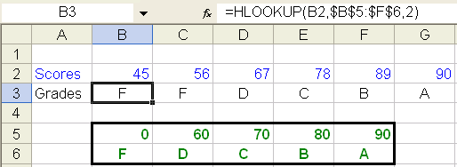

Section 3-2: Workbook – Referencing across Worksheets

1. A workbook contains multiple worksheets.
2. Worksheets are identified with their names shown in the worksheet tabs. The name of a worksheet can be renamed in the same way as you rename a file.
3. When you need to refer to a cell in ANOTHER worksheet, use the format in the following example (assuming you want to calculate total cost):

Total Cost = Fixed cost + Volume * Variable Cost

If each of the values is in the same cell address on different sheet, say B1 on sheet "FixedCost" stores fixed cost, B1 on sheet "Volume" stores volume, B1 on sheet "VariableCost" stores variable cost, B1 on sheet "TotalCost" is the formula that you are creating to calculate total cost, then you have in sheet "TotalCost", cell B1 the following formula:

=FixedCost!B1+Volume!B1*VariableCost!B1

where the "!" means "sheet".

You can do sum or average across sheets in a similar fashion, for example:
=average(sheet1!g3, sheet2!g3, sheet3!g3) or =average(sheet1:sheet3!g3)

Section 3-3: Conditional Formatting

Assume that you are an analyst hired by XYZ Company to analyze their product quality. XYZ Company recently had some customer complaints on the quality of some products they produced. XYZ Company believes that their production processes are in normal performance; but to be sure, they want you to run some statistical analyses to verify that. Assume that you decide to run a t-test to determine whether the quality indicators of a wide range of products are significantly different between Q1 and Q2. After you find the p value, you could use eye-ball examination to find out those significant values (p<0.05). However, if the number of data points to be examined is a large one (which is often the case), the eye-ball examination would be very tedious and error-prone.
To ease this task, you can use the wonderful feature of conditional formatting offered by Excel (and all other electronic spreadsheets). Steps to perform conditional formatting:

- Highlight the cell range that you want to format;
- On the menu bar, select Format, then Conditional Formatting.

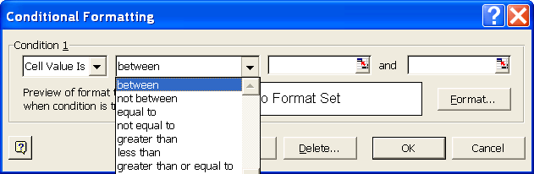

Figure 3-4 The dialog box for conditional formatting

- You can then select from the drop-down list the logical relationship you need. Here you want to select less than.
- Then you want to fill out the value(s) in the slot(s). Here you only have one value, which is 0.05. Fill it in the first slot. (What if you want to set the condition “between 0.05 and 0.1”? Think and try)
- Click the Format button, and you will see a Format Cells dialog box pop up. You can then choose the format you want, such as red color. Click OK, and see this:

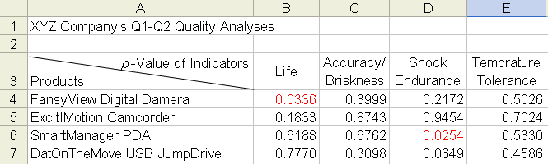

Figure 3-5 The results of conditional formatting

Section 3-4: Sorting a Spreadsheet
IntelliImage, a company selling digital camera, digital camcorder (DV), and scanners, has four sales regions - Las Vegas, Los Angeles, Phoenix, and San Francisco. The following table shows the digital camera and DV sales of IntelliImage in the four sales regions.

 | A | B | C | D
4 | Sales ($million) | Digital Camera | DV | City Totals
5 | Las Vegas | 20 | 9 | 29
6 | Los Angeles | 14 | 11 | 25
7 | Phoenix | 8 | 3 | 11
8 | San Francisco | 18 | 7 | 25
9 | Product totals | 60 | 30 | 90

Figure 3-6 Sales data of IntelliImage

The VP for Marketing of IntelliImage would like to see the sales regions listed according to their sales performance, highest first (descending). Here is what you would do:

(1) Highlight A4:D8 – data, city totals, and the column headers, but NOT “Product totals”: you want to leave the product totals as the last row.
(2) Select Data on menu bar, select Sort, and a sort dialog box will appear as in Figure 3-7 below.
(3) You want to sort by City Totals. Click at the down-arrow button at the sort by box and a drop-down list of fields would allow you to choose City Totals you want to sort on.
(4) If you want to sort on a different field when there are more than one row having the same city total, you can then choose a field in the Then by box. This would be your secondary sorting field.

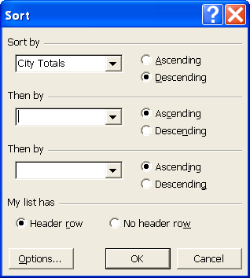

Figure 3-7: Sort by City Total

(5) Click OK and your data is sorted!
(6) Similarly, you can sort on other fields such as Digital Camera or DV.

